***Business Reason***

Republic Services would like to add the Site Number to the accounts info. This will help when selecting the correct site for a customer when they have multiple sites.

***Task Requirements***

1. Take the site number and add it to the Site name.
   1. Ex.

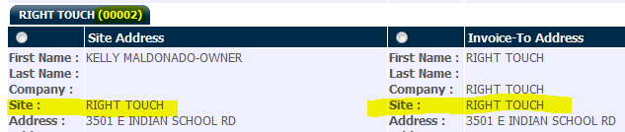

* 1. Site: RIGHT TOUCH - 00002

***Build Plan***

1. Once accounts information is passed to Capture, we do not modify the information. What you send to specific fields is what you will see.
2. Thus, Republic Services should add the site number to the site name in the accounts uploads.
3. Republic Services would need to re-upload all of the existing accounts to Capture. This should be done in **DEV first** and then test and prod. Do not change the prod upload until the DEV one has been tested.
   1. Accounts Fields:
      1. billing_id contains the site number.
      2. billing_company_2 and shipping_company_2 contain the site name.
         1. Ex.

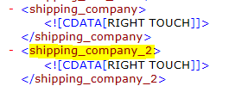

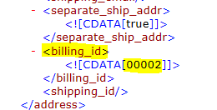

***Admin Guide Changes***

Yes. The accounts information is pushed to Capture by the Republic Services team. The billing_id information is included in the shipping_company_2 and billing_company_2 data. This is how we get the site name and site number in the site line.

***User Guide Changes***

None.